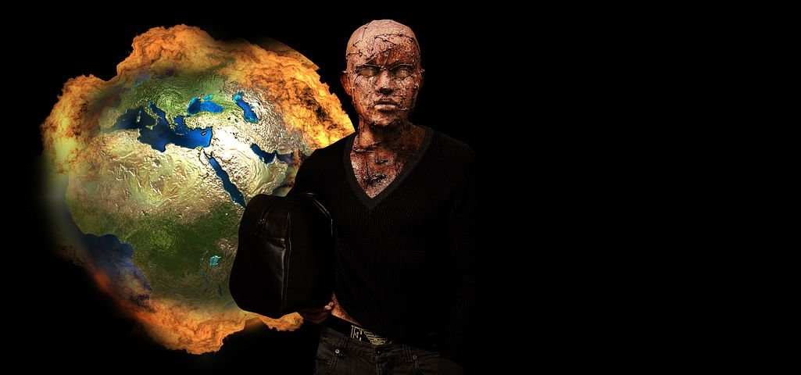

WHEN SALVATION IS IMPOSSIBLE
Episode Nine: Revelation 8&9

In Revelation 8&9, great plagues are unleashed from the war room as warnings of greater disasters to come: intense global warming, ecological meltdowns, and demonic cruelty. The Paris Peace Accords will prove useless, as will the promises of the New World Order. Instead of softening hard hearts of creation worshippers, these catastrophes will only stiffen rebellion against their Creator.
Those who would navigate the New World Order must be prepared for the implacable heart of delusion that is already manifested in our present day.

- The Church Raptured between Seal Six and Seal Seven. [Revelation of a parenthesis moment between the end of chapter six and beginning of chapter eight, in which we are introduced to the saints of the ages, as well as those who went through the first part of the Great Tribulation. Your Teacher holds to a Pre-Wrath Position, sometimes referred to as a Mid-Tribulation Rapture. When God pours his final wrath out upon the world, the church, along with the restraining Holy Spirit, will be gone. See 2 Thessalonians 2].

- The Great and Awful Seventh Seal. “And there was silence in heaven for about a half hour… [Revelation 8:1] After a nonstop cacophony of praises and a kaleidoscope of activity, everything stops. Not a whisper can be heard. Awe and dread fill the place. God is about to go to all-out war against those who remain on the earth. “The angel took the censer and filled it with fire from the altar and threw it to the earth, and there were peals of thunder, rumblings, flashes of lightening, and an earthquake.” [Rev. 8:5]

- Remember, the fire from the altar comes from the same place that the martyrs are huddled under it, crying, “O Sovereign Lord, holy and true, how long before you will judge and avenge our blood on those who dwell on the earth?” [Revelation 6:10]. Then they are told “to rest a little longer.” This is during the fifth seal, just before the sixth is opened. The reason they must wait is that “the number of their fellow servants should be complete, who were to be killed as they themselves had been.” [Revelation 6:11] These are those fellow-martyrs who are left to be killed during the Great Tribulation, that Christ speaks of in Matthew 24. These are among those described in Chapter Seven of Revelation, all now in heaven, along with the rest of the saints, prior to Chapter Eight and the Wrath of God poured out in keeping with the pleading of the martyrs in Revelation 6:10.

- The Seven Trumpets [Revelation 8:2-6] These are the trumpets of war. Seven of them means that God is going to all-out war. The Great and Terrible Day of the Lord is beginning. Heaven is coming to earth in final fury!

- Trumpet one: Fire from heaven. A third of the earth is left in ashes. [Rev. 8:7]

- Trumpet two: Something like a Great Mountain [could it be an asteroid?] crashes into the seas. A third of the seas are left dead. [Rev. 8:8]

- Trumpet three: Something like a comet [or maybe nuclear bombs] hits the fresh water. Called “wormwood.” In the Russian Bible, wormwood is translated Chernobyl. A third of the fresh water supply on earth becomes something like nuclear waste dumps. [Revelation 8:01&11}

- Trumpet four: Disaster in the solar systems. The earth is plunged into a kind of artic night. [Rev. 8:12] Do you think the Paris Climate Accords will stop this?

[A terrible pause: The eagle cries, “…woe, woe, woe…” [Revelation 8:13] Three woes remind us of the Trinity—this is the number of God. When God brings “woe” it is terrible beyond reckoning or imagination. Prepare for the last three trumpets. As bad as things have been, they are going to get so much worse. Heaven has only paused to catch its breath before the final onslaught of wrath].

- Trumpet Five (the first woe): The fallen angels and demons of hell are unleashed to terrorize the earth. If this were a horror movie the title would be The Endless Night of the Living Dead. [Rev. 9:1-12]

- Trumpet Six (the second woe): A Great World war, a 200 million-person army from the East, and a third of humankind slaughtered. The heavens have turned on the wicked earth, hell has tormented it, and now humankind turns on itself. One-third of creation and its creatures are now dead. [Rev. 9:13-19]

- Yet, hearts are irrevocably hardened toward God. [Revelation 9:20-21] No one will be saved after the Rapture of the Church. How can they be, when the Holy Spirit has been removed along with the Bride of Christ?

- Paul speaks of the “Man of Lawlessness” [the final great Antichrist] who will come offering peace [2 Thessalonians 2:1-12], who will also persecute the Christians. Jesus speaks of him when he talks about the Second Coming. He too speaks of the Antichrist, “the abomination of desolation” and the great tribulation Christians will undergo. [Matthew 24:3-28] He speaks of the fourth trumpet that will happen not long before His Coming. Both Jesus and Paul forewarn that people will be deluded by promises of peace from the Antichrist and his Babylon Beast [final New World Order]. 78% of Millennials and Gen Z’s today believe that the Government is the answer to all our problems, from racism to climate change.

- But the church will be raptured, and the Restrainer taken away. [2 Thessalonians 2:7] Then the utter evil and impossibility of salvation will be on the earth that faces the final wrath. They will be like Pharaoh whose heart was hardened after all the plagues.

- A two-fold warning for us today:

1) Stand strong today. Delusion is on its way for those Christians who buy into the siren call of the New World Order. Tribulation is certain for those who stand against the lies of the New Babylon. [1 Thessalonians 5:1-11]

2) If you haven’t received Jesus before the Rapture of the Church, it won’t be possible afterwards. And that moment could come in a flash. [2 Thessalonians 5:4-8] You don’t want to be left behind to face what’s coming next, and the hell that follows.

