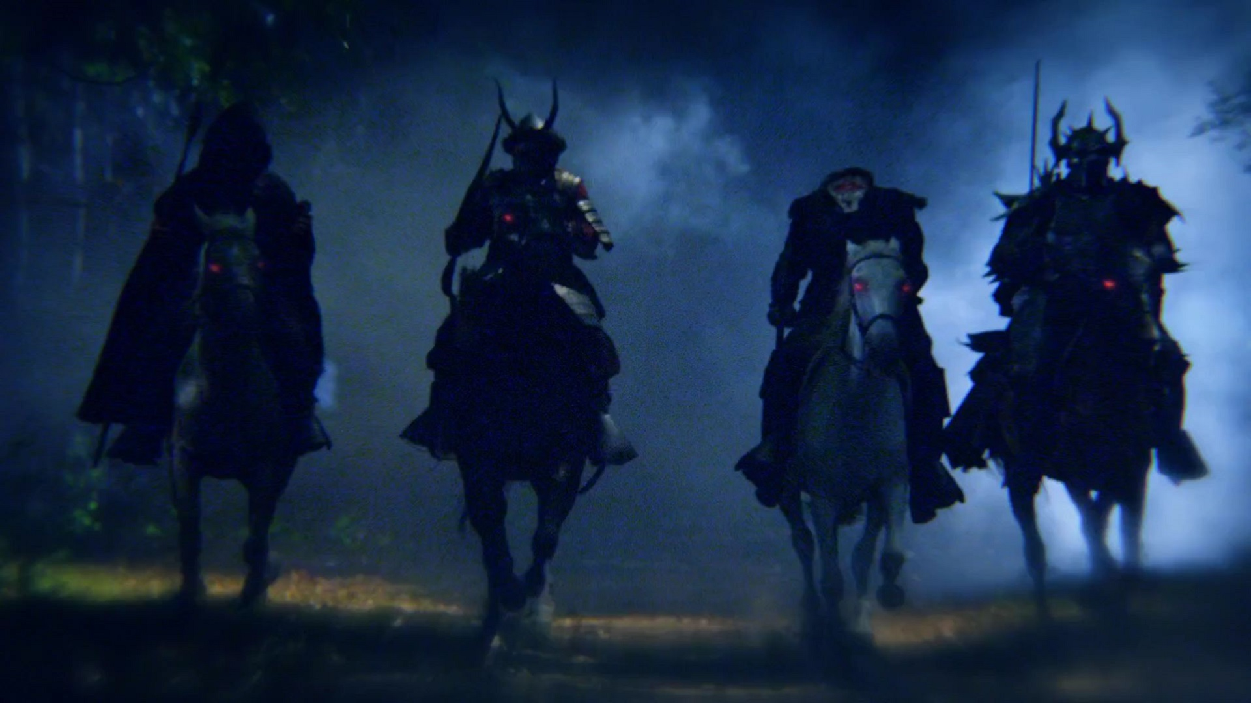
THE ROARING LAMB & HIS FOUR HORSEMEN
Episode Seven: Revelation 6

Too many folks see Christianity as a smorgasbord from which they may choose the delectable and pass by the distasteful. These fair-weather believers prefer a gentle Lamb who indulges their whims. Revelation 6 destroys that myth. He is a Roaring Lamb who sends the dreaded Four Horseman of the Apocalypse to ravage the earth. Who are these ghost riders in the night skies? If we listen carefully we can already hear their hoofbeats galloping across near horizons. What do they portend for us and our New World Order?

- The Revelation Code Revisited: The numbers of these seals have deep symbolic meaning in biblical numerology. There are seven seals on the scroll of history. This is God’s number, as well as that of perfection. History belongs to God, and it is perfectly packaged. Only Jesus can open these seals because all of history has to do with the redemption that He alone has accomplished as “the Lamb slain before the creation of the world.” [Revelation 13:8]

- “And I watched as the Lamb opened the first of seven seals.” [Revelation 6:1] Literally, “ripped” or “tore off.” Jesus takes over history with fierce authority. This is judgment time on the earth. Watch each seal, and other judgments in the coming chapters of Revelation: progressive judgment. This is a reminder of the plagues God sent to judge Egypt—each successively worse, until the final and awful Death Angel came. God sends catastrophes, plagues, famines, and destruction to warn and break us, lest we face his full fury and final wrath!

- The Number Four: First four seals, four living creatures and four Horseman [Revelation 6:1-8] “…four living creatures say in a voice like thunder, ‘Come!’” Four is the number of creation [in Genesis one, the creation was finished in four days; the last two days were spent filling the creation with creatures].

- Creation thunders. Remember, creation belongs to Jesus, the Lord over all creation. The mighty forces of creation to give, take, and destroy are part of the Lamb’s arsenal in the War Room. At His command, creation now turns on the creatures who have both worshipped and abused it.

- Humans, in their arrogance, think they can use the creation, and create from its materials, all they need to replace the Creator. They believe that the creation created itself and them. That its bounty can be harvested to sustain them. When they die, they return as so much fertilizer to their god, creation. Their greatest fear is that their source of life will itself die—hence the great angst about global warming, the extinction of animal species, and other existential ecological catastrophes. In their arrogance, humans think that they can build systems, governments, and peace accords to stem the death spasms of earth, or to find another planet or build a colony in outer space before it’s too late. Instead, all they manage to do is further exploit and destroy the creation that God gave them as a gift. They will not escape what they have turned into a death trap.

- Each of the four horseman who ride forth, as the first four seals are torn off the scroll of history, are symbolic of the earth rising up, at the command of the Roaring Lamb, as partial judgments to rebellious humans: “The false gods which you serve [in this case, creation, creature comforts, systems made by the creature, and all its utopian dreams of the creature trying to restore paradise on this earth] will only destroy you! The Paris Peace Accords, getting rid of carbons in the atmosphere, and all the other efforts to heal a sick planet will not work. It’s too late. The end is coming! Get right with the Creator while there is still time! Creation won’t save you!”

- As an application: Christians ought to beware of skepticism about global warming and other ecological disasters. Though the progressive left may be hysterical about it, it doesn’t render their anxiety wrong. Everything they predict is coming, and even worse. As we shall see in our study of Revelation, the earth is headed for an ecological meltdown.

Where we might differ regarding such issues as climate change, is in the cause of these looming ecological disasters. Whether they are man-made, nature-made, or God-made, it matters little. It is with prophetic certainty that ecological catastrophes will come as God’s judgment on creation-centered, rebellious humankind.

Where we would be diametrically-opposed to the New World Order is in the idea that man, or his solutions, can change the inevitable flow of prophetic history. We might even predict that it will be the inability of individual nations to stop global terrorism, international financial collapse, or ecological disasters that will give rise to the final world order [the great final Beast, its seductive Babylon face, and Antichrist leader] In the end, the four horseman and subsequent wrath, will be too much for those who stand against the Roaring Lamb who is also the Lion King.

A CAUTION: These inevitable ecological meltdowns don’t mean that we Christians shouldn’t care for our environment. As stewards of the creation God gave to bless us, we should we the foremost ecologists in the world. We are responsible to be good stewards of everything that the Four Horseman are about to dismantle. The difference is that we don’t put our trust in this creation or its survival, but in the Creator who will one day give us a new heaven and new earth to enjoy forever.

- Seal One: The Rider on the White Horse. [Revelation 6:2] The antichrists who come as saviors, like Nimrod in Genesis 10, to gather all the people into their version of a utopia. After he killed one-million people in establishing his great empire, Alexander the Great said in one of his final declarations, “I did all this to bring the peoples of world together in peace.” This is the dream of the original Babylon [Genesis 11]. The Creator made the original paradise out of nothing, but the conqueror attempts to build subsequent paradises out of creation. Instead, this first horseman will bring the other three in his terrible wake.

- “…he was given a crown…” [Rev. 6:2] God elevates these conquerors to power so that they will bring judgment. Remember King Saul? The people wanted a king to fight their battles for them. So God gave them exactly what they wanted. Saul was His judgment on Israel, and some of the very people we vote into office turn out to be God’s judgment on us.

- The Second Seal: The Rider on the Fiery Red Horse [Revelation 6:3-4]. Wars among nations bring death and destruction. The world has been without a war in only eight percent of its history (264 years in its last 3400). Over a billion people have been killed in wars. The 20th Century was the bloodiest with 120 million killed. Yet, in less than a minute, a U.S. nuclear Trident submarine can unleash more killing power than all the explosives from all the nations in World War 2.

- The Third Seal: The Rider on the Black Horse. [Revelation 6:5-6] Economic catastrophe. The latest Global Peace Index said that the cost of war to the world economy in 2015 alone was $13.6 trillion. There is a reason that the words “peace and prosperity” are always joined together like Siamese twins. War is almost always over who controls real estate and its resources. In the end, creation takes far more than it gives when war and destruction plague the earth.

- The Fourth Seal: The Rider on the Pale Horse. [Revelation 6:7-8] Death comes in many ways on a planet racked by the rider on the white horse. When creation is devastated by war, anarchy [death by the sword], famine, and plague, and an infestation of wild beasts—all caused by the breakdown in order—leave worse devastation and death than that on the battlefields. For example, in the Second Congo War (1998-2003) only a few thousand combatants were killed. Civilian deaths were 5.4 million, along with starvation, disease, and whole villages, towns, and cities made uninhabitable. Yet, most of the world paid little attention to this holocaust of Revelation six proportions! Multiply this over history, or even the last century, and the numbers would be staggering. Indeed, as Revelation 5:8 says, “…over of fourth of the earth…”

- The Fifth Seal: The Suffering Church. [Revelation 6:9-11] These are the martyrs of every age, and those of these last days. More Christians were martyred in the 20th Century than the total of martyrdoms in the 19 centuries proceeding it. The numbers of martyrs continues to grow in the 21st Century—from Christian genocide in Nigeria; to mob violence against churches in India; to Christians in slave labor camps in China, making tennis shoes for hypocritical NBA millionaire players who fight for social justice in America.

- If God didn’t judge the earth, he wouldn’t show love and justice toward those who love him most. “How long, O Lord?” [Rev, 6:10]

- The Lamb will not open the seventh seal until all those destined for martyrdom have been killed [Rev. 5:11]

- If you are destined for persecution or martyrdom, remember that this is the fifth seal. The number five stands for God’s grace. To be chosen for that unique and intimate fellowship in Christ’s sufferings [Philippians 3:10] is an act of God’s grace. You will have a special place in heaven, under his altar [Revelation 5:9]. And you will be given the grace to stand strong through it all [Revelation 5:11].

- The Sixth Seal: Ecological Disaster on a Catastrophic Scale. [Revelation 6:12-15] Six is the number of humanity. Adam and Eve were created on the sixth day. 666 is the number of the Beast: man who is 6 playing God whose number is 3 equals 666. And now man, who worships the creation and creature (the chief creature being himself or herself), sees his god collapsing and falling in on him.

- Is all this literal or symbolic? It matters little. The point is: all of creation is going to turn, with all of its fury, on those who worship and exploit it.

- Even in the end, the great and the small, will still cling to the creation. As their Creator comes with fury, instead of prostrating themselves in terror, or bowing down in worship, they will still turn to creation for their salvation. “They call to the mountains and the rocks, ‘Fall on us and hide us from the face of him who sits on the throne.’” [Revelation 5:16]

- We see here, and will see it again in Revelation, the utter depravity of sinful people. Even when all they put their trust in fails them, and the wrath of God is at hand, they still cry out to all that has repeatedly failed them to save them.

This is why we must never forget, during these days of increasing sin, that Jesus did not come to make bad people good. He came to make dead people come alive. Unless people are born again, they are in a hopeless place. We are not called to make America great again. Rather, to be part of redeeming the lost before God removes his saving grace from the world!

